Walk 34 Ledbury to Frith Wood
Last walked in February 2016

Description. 8 km (4.9 miles). A delightful all-seasons walk. The outward walk is along tracks and footpaths which - even if the grass dampens your trousers - do not usually get muddy.
Start. The Market House, Ledbury. Explorer Map 190. Grid 711377.
Directions from Whitecross Roundabout (Turn milometer to zero). Take the A4110 Canon Pyne (Three Elms road) for 1 mile and TR at the traffic lights onto the A4103 Worcester (Roman road). After 7.7 miles TR, signposted to Stoke Edith. After 9 miles TL at road junction (not sign posted) onto main road to Ledbury. Reach roundabout at 15.9 miles and go straight across heading for the Town Centre. Go thru town centre and at 16.9 miles TR at the clock tower that is on the R (on the L is the Market House), and go a little way down Bye Street to TL into a car park.

1. Ledbury Market House. The Market House dominates the centre of Ledbury. The celebrated “King’s Carpenter”, John Abel, built this brick and timber structure in 1653. Its original use was as a grain store, and it is now used as a council meeting room. Leave the Market House by going up Church Street - care! not Church Lane! Church Street was formerly called Hallend, then Back Lane. This road was probably the beginning of the early route from Ledbury to Worcester. The road climbs a little, and as it turns L, you continue straight ahead on a steeper pedestrian pathway. (A plaque built into the wall at low level tells you this is Green Lane, an ancient packhorse road to Worcester.) After 150 yards or so you reach track junctions, (a green metal bench and a rubbish bin is opposite), take the wide track going broadly straight ahead, keeping the bench to your R as you do so, (ignore the smaller track on your L). Continue along the enclosed wide track, staying just inside the wood and passing the odd bench or two to sit down on.

2. Minor Road. When the track meets a road, go straight across to a road opposite which immediately bends R and goes down hill before turning L. There are views on your L down to Ledbury Railway Station, a truly 'Thomas the Tank Engine' type railway station, with a small wooden ticket office and waiting room. A little further on the road bends to the R and a short distance further you go thru a small metal kissing gate on your L, signed as footpaths LR21 and L19. Continue in the same direction as before, keeping to the R of the metal gate, and walk along the top edge of a field, keeping the boundary fence/wood to your immediate R. The path then goes thru a small metal gate, ignore the wooden gate on the L, and go thru a small garden of a house. As you go thru another metal gate into an orchard you turn sharp R. Keep to the edge of the field as it goes up and turns L. Keeping the wood on your R you then continue along the field boundary until you arrive at the end of the orchard field R next to a road on your L. Don’t go onto the road just yet but keep in the same direction, following way markers as a track goes slightly into the wood and passes a house on the L and meets up with the road further along.

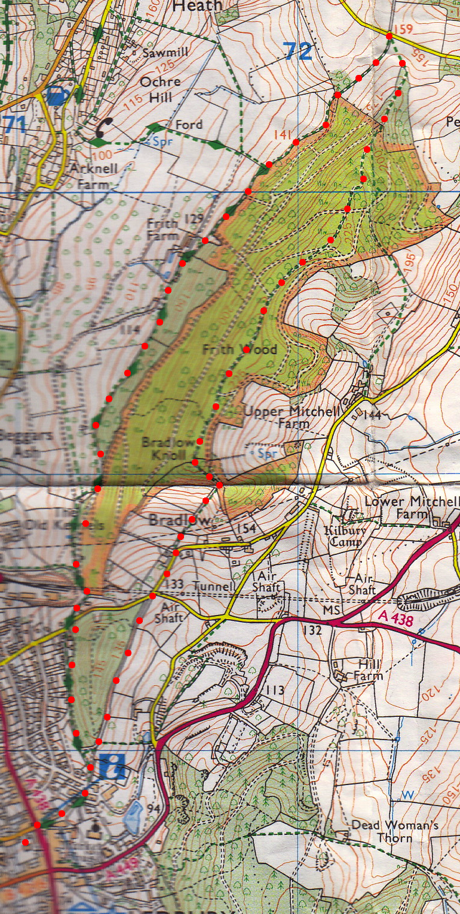
3. Road. TR and go along the road. Pass a house on the R and then reach a house on the L, the last house along the road/drive (but not the last building). Opposite this house and on your R you go round a wooden gate and follow the track, signposted the Geopark Way. The track will soon have a wire fence on your L, which you follow; this eventually meets up with a wide track where you TL and continue on to meet up with a road. When you get to the road you do a U turn to your R and go over a stile, signed as footpath CW57, and into a field. Walk up and across the field, heading for wooden gates that are at the end of Frith Wood. Go thru the gate(s) and continue along the path ahead of you. And on thru the wood.
4

4. Frith Wood. It is mixed woodland with oak, silver birch, rowan, ash, beech, sycamore and holly (once grown as fodder for sheep, cattle and deer). The wood is rich in bird life and the quiet walker may see a variety of species from the quiet tree creeper to the flamboyant jays and magpies. There is a cross of paths, ensure you go straight ahead, and continue upwards on a narrow, sometimes muddy path signposted Top Walk - DO NOT take the broad track going L or R. Continue in the same direction and ignore any way marked tracks L or R, continue up and along the ridge for about a kilometre until you eventually reach the end of the track at a track junction, by a sign saying ‘Bradlow Knoll’, the highest point in the woods. TL, and go down a well-made flight of 54 steps. Follow the track and go thru a small wooden gate and down some wooden steps into a field. Go down the R hand edge of the field and thru a metal gate at the bottom, down a short enclosed green lane and thru a wooden gate and onto the road where you TR.
3

5. Cut Throat Lane. At the T junction - a nameplate says you are on Cut Throat Lane - go straight across, round a gate and continue along the broad track which takes you straight back to the Town Centre. (When you reach the forked track junction by the green bench take the L fork).
5
2
1

